The George Washington University

CASE 2

Econometrics SAS

Tiffany Tiono, Gamdan Abdullah, Aditya Tyagi

FINA 6271

Professor Semaan

28 September 2020

1. 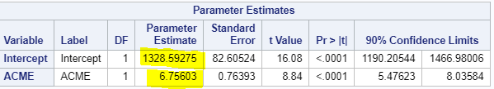

**Y = 1,328.59+6.756X+U**

1. Null Hypotheses = 0

Alternative Hypotheses ≠ 0

Using 90% of CI, the t-critical is 1.298.

As the t-value = 8.84

Since the 8.84 >1.298, **we accept the alternative hypothesis** so we are fairly certain that return on the market provides predictability of the return on ACME in the population.

1. Y= 1,328.59+(6.756*0.02) = **1,328.72512**
2. 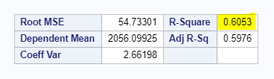

Coefficient of Determination= **60.53%**



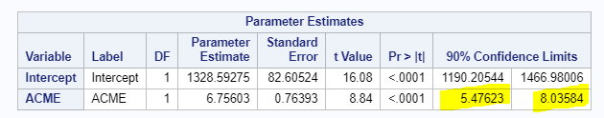

CI Upper Bound= Y= 6.75603+(1.675*0.76393) = 8.03561275 = **8.036**

CI Lower Bound= Y= 6.75603 - (1.675*0.76393) = 5.47644725 = **5.476**

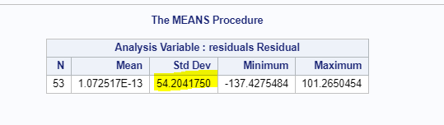

Standard deviation = **54.20**

1. SAS Code:

